THE TITLE OF THE PAPER IMPACT FONT TYPE, 16 POINT, BOLD, CENTERED

First and last name of each author in Times New Roman font type, 14 point, center, for example Rudy Aernoudt^{1*}
¹ Author affiliation: University, city, country. Times New Roman, 10 point
* Correspondent author: First and last name – email address
Received:
DOI:
Category:

ABSTRACT
A single paragraph of about 250 words maximum. The entire paper will be written using Times New Roman font type, 12 point, alignment: justify, line spacing: 1, paragraph spacing: 6 pt before and after each paragraph. The abstract must include sufficient information for readers to judge the nature and significance of the topic. It should summarize the objectives of the article, methodology, results and conclusions. In order to increase the visibility of the article, the abstract should reiterate key words and phrases while avoiding unnecessary repetition.

Keywords: Four to seven keywords (words or expressions) that capture the essence of your paper should be listed in decreasing order of importance, ensuring consistency with the title and the abstract of the article.

1. Introduction

The body of the paper will be written using Times New Roman font type, 12 point, alignment: justify, line spacing: 1, paragraph spacing: 6 pt before and after each paragraph. An empty row will be introduced before every subtitle. All subtitles will be numbered.
The introduction familiarizes the reader with the context of the paper. It must reflect, briefly, current research in the field and order approach presented in the article.

2. Paper Body
The paper should be the result of a research in the area, corresponding to the specific topic of the journals’ issue. The structure of the paper should be clear and well emphasized by titles and subtitles placed in a logical sequence, according to the writing methodology of the scientific papers. In order to allow the readers to understand better the work of the authors, the following structure of the paper will be used: Review of the scientific literature, Research methodology, Results and discussion.

For lists unordered bulleted lists will be used:
- This is the first item on the list. In case of sublists, unordered lists with dashes will be used, as follows:
  - first subitem
  - second subitem
- Second item on the bulleted list
- Last item on the bulleted list.
Tables and figures should be placed in the body of the paper exactly where the authors want them to appear printed and be of the size desired by the authors. We recommend that the tables and figures fit on one page and be inside the margins of the paper. Graphs must be uncluttered and easy to read, preferably in black and white. Tables and figures will be numbered. Their content will be written using the Times New Roman font type, 12 point. The heading should be in Times New Roman font type, 12 point, bold, positioned above the corresponding table or below the corresponding figure. Please indicate the source of data when appropriate (in Times New Roman font type, 10 point, italic, center, below the table or figure). References to tables and figures must be made within parentheses in the text of the paper, e.g.: (figure 1), (table 1).

Example of a table:
Table 1. Comparison between policy methodologies

Methodology | Opinion  -based | Evidence  -based | Foresight  -based
Input | Volatile opinions | Rational  evidences | Possibilities
Timeframe as starting point | Present | Past & present | Future
Timeframe as objective | Short-term | Mid-term | Long-term
Delivery | Convictions | Forecast | Foresight
Target | Common denominator | Result | Process
Method | Common knowledge | Statistical methods,  Empirical observations Econometric models | Brainstorming  Hackathons
Approach | Emotions | Rational &  science-driven | Rational & creativity-driven
Mapping | Feelings,  Perception | Data,  Parameters | Megatrends, change drivers
Degree of certainty | Assumptions | Almost certain (high level of confidence) | Probable, plausible, likely
Source of knowledge | Lobby-groups, civil society | Expert groups,  academics | Heterogenous participants
Outcome | Push to action | (mostly) Clear-cut advice | Scenario's
Source : Aernoudt, 2020.

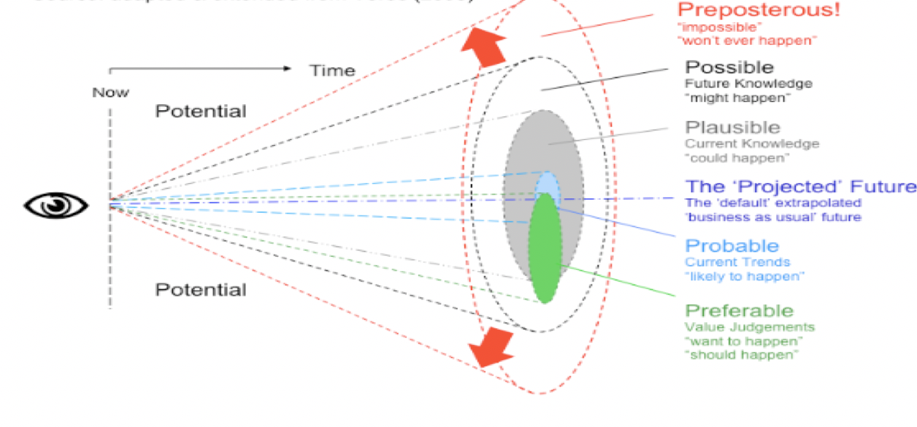

Figure 2. Scenarios based on foresight exercise, adapted from Aernoudt, 2020.

2.1 Equtations and formulas (Heading 2)
Equations and formulas should be numbered. The numbers are to be justified to the right, within parentheses.
Examples of equations:
IGDPc=IE^{α} ICKc^{(1-α)}ITFP (1)
where:
IGDPc – index of GDP in constant prices
IE – capacity utilization index
α – elasticity of industrial output
ICKc – index of active assets at constant prices
ITFP – productivity index.

2.1.1 Abbreviations and acronyms (Heading 3)
Abbreviations and acronyms should be defined the first time they are used in the text.
Examples of abbreviations and acronyms:
soc. – sociology
cyb. – cybernetics
ec. – economy
ICT – information and communication technology
CEEC – Central and Eastern Europe Countries
CSR – Corporate Social Responsibility
GMES – Global Monitoring for the Environment and Security
MRA – Mutual Recognition Agreement

3. Conclusions
A conclusion section is required. Conclusions should provide a synthesis of the main contributions of the paper, discuss the importance of the work, and/or suggest possible applications and extensions of the research.

References, Times New Roman 11, line spacing 6 (before and after)

For books: Surname, initials (year), title of book, publisher, place of publication.
Aernoudt, R. (2020), Entrepreneurship, No Guts, No Glory. Intersentia, Cambridge, UK.
Flyvbjerg, B. (2001), Making social science matter: Why social enquiry fails and how it can succeed again. Cambridge University Press, Cambridge, UK.

For books chapters: Surname, initials (year), "chapter title", editor's surname, initials (Ed.), title of book, publisher, place of publication, page numbers.
Roblek, V. (2019), "Smart city Vienna", Anthopoulos, Leonidas G. (Ed.), Smart city emergence: cases from round the world, Elsevier, Amsterdam, NL, pp.105-127.

For journals: Surname, initials (year), “title of article”, journal name, volume issue, page numbers.
Aernoudt, R. (2020), “Evidence – and foresight-based policy: dichotomy or overlap? World Complexity Science Academy Journal, Vol. 1 No. 1, 14.
Horton, A. (1999), “A simple guide to successful foresight”, Foresight, Vol. 1, pp. 5-9.

For published conference proceedings: "title of paper", in editor’s surname, initials (Ed.), title of published proceeding which may include place and date(s) held, publisher, place of publication, page numbers.
Roblek, V. and Meško, M. (2020), “Smart city knowledge management: Holistic review and the analysis of the urban knowledge management”, in Eom, S.J and Lee, J. (Ed.s), Intelligent government in the intelligent information society: the proceedings of the 21st Annual International Conference on Digital Government Research (DGO2020), June 15-19, 2020, Seoul, Republic of Korea, The Association for Computing Machinery, New York, NY, pp. 52-60.

For newspaper articles (authored): Surname, initials (year), “article title”, newspaper, date, page numbers.
Fangfang, L. (2020), “Delivering services innovations to drive post-pandemic growth”, Bloomberg Businessweek (Europe), 5. October, pp.6-7.
For newspaper articles (non-authored: Newspaper (year), “article title”, date, page numbers.
Bloomberg Businessweek (Europe), “Delivering services innovations to drive post-pandemic growth”, 5. October, pp.6-7.

For electronic sources: Surname, initials or publisher name (year), “title of electronic source”, available at: persistent URL (accessed date month year).
Deloitte (2012), “Econometric analysis for scenario-based planning”, available at: https://www2.deloitte.com/content/dam/Deloitte/ie/Documents/Strategy/econometric_analysis_for_scenario_based_planning.pdf (accessed 3 May 2020).
OECD (2017), “The role of foresight in shaping the next production revolution”, The next production revolution, Implications for Government and Business, available at: https://www.oecd-ilibrary.org/science-and-technology/the-next-production-revolution/the-role-of-foresight-in-shaping-the-next-production-revolution_9789264271036-13-en: pp. 299 – 324 (accessed 6 May 2020).

This article is distributed under the terms of the Creative Commons Attribution 4.0 License (https://creativecommons. org/licenses/by/4.0/) which permits any use, reproduction and distribution of the work without further permission provided the original work is attributed as specified on the WCSA Journal by World Complexity Science Academy (https://www.wcsaglobal.org/ethics-policy/).

